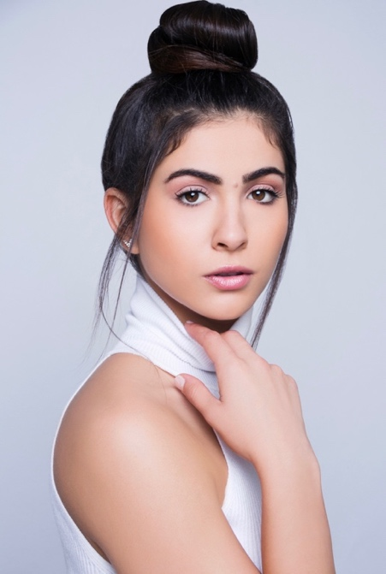
Amel T.
Rochester, NY

Objective: Seeking Modeling and Acting Projects

Hair Color: Brown Height: 5’4
Eye Color: Brown Weight: 121

Summary of Qualifications
- Sound Knowledge of body posture, movement and facial expressions.
- Thorough knowledge of make-up, hairstyles and fashion.
- Uncommon confidence, patience and punctuality.
- Remarkable ability to adapt and be able to accept criticism.
- Possession of huge professionalism and concentration of duty.
- Exceptionally attractive skin and personality.
- Great coordination, flexible body, clear speech, tidy appearance, and immensely fit and healthy.

Education
- Bachelor of Arts, International Studies and Legal Studies at Nazareth College Rochester, New York 6/13-8/17

Professional Experience
John Robert Powers Rochester, NY Rehearsals 2018
- Gained knowledge of professional models’ appearance such as body awareness, body control & movement, nutrition, figure process, agents, managers, and self promotion.
- Mastered basic posing techniques, developed a model’s bag, and wardrobe selection for showcase.
- Prepared for commercial print audition techniques, agency procedure, reviewed photos for showcase, comp cards, mock audition, and dress rehearsal.

Regional Showcase: Crowne Plaza Syracuse Hotel
- Began showcase by distributing comp cards to the agents.
- Stated my name, age, and who I was represented by.
- Completed my four poses and thanked the agents.

MMG Model- Talent- Celebrity Management – New York, NY 2019
- Modeling portfolio photo-shoot; 4 look photo-shoot including hair styling and make-up artist. Also includes 6 high resolution retouched images, digital copies and copy rights to all usable images resulting from photo-shoot.
- Wardrobe Stylist: Professional wardrobe stylist to prepare and assist during photo-shoot.
- Cooperated with stylist and photographer to ensure shoot went smoothly.

WMA – Rochester, NY 2019 – Current
Amazon Photoshoot: Syracuse, NY
- Posed for several showerhead shoots in the shower for four hours.

Louisiana Hot Sauce Photoshoot: Syracuse, NY
- Created a fun, energetic, friendly atmosphere with other models and posed as directed.
- Featured on Louisiana Hot Sauce Instagram account.

