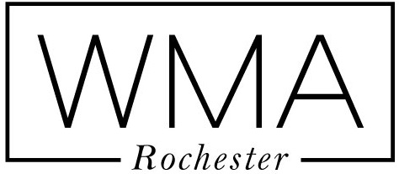 **Thomas Hamon**

WMA Rochester Height: 6’1”

235 Alexander St Weight: 195

Rochester, NY 14607 Hair: Brown

585-244-0592 Eyes: Brown

**Training**

Acting for Commercials W Evolve Studios Billy Powell

Auditioning and Casting W Evolve Studios Billy Powell

Photo Movement W Evolve Studios

**Special Skills**

Weightlifting, Nutrition, Car Enthusiast